How to Create a PowerSchool Parent Portal Account
To create a parent account select the link from our webpage or use the direct web address below.
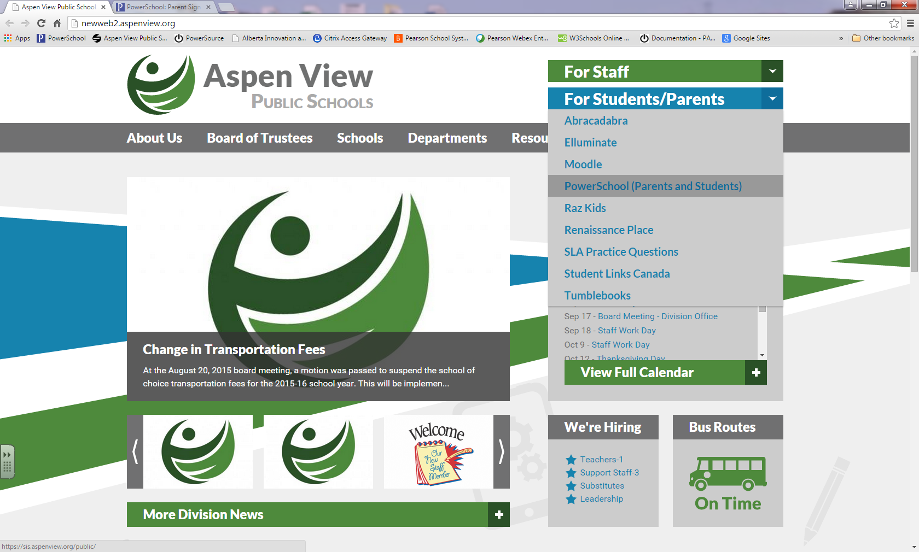

https://sis.aspenview.org/public/

From the parent portal sign in site select the tab ‘Create Account’ and follow up with clicking on the blue ‘Create Account’ link at the bottom of the account setup box.

Enter the information in the fields as per the examples.
You will find the Access ID and Access Password information for your child/children from a letter received from your child’s school. If you do not have this information it may be requested from the school office.

When you have entered all your information, click on enter at the bottom of the page. You need information for at least one child to set up an account, but are able to add additional children via Preferences in the portal once the account is set up.
Once you have set up your account, you should be able to return to the Sign In page and log into your account using the username and password that you set up for yourself.

To add an additional student to your account select ‘Account Preferences’ from the left hand menu, click on the ‘Students’ tab and then click on the blue ‘Add’ link.
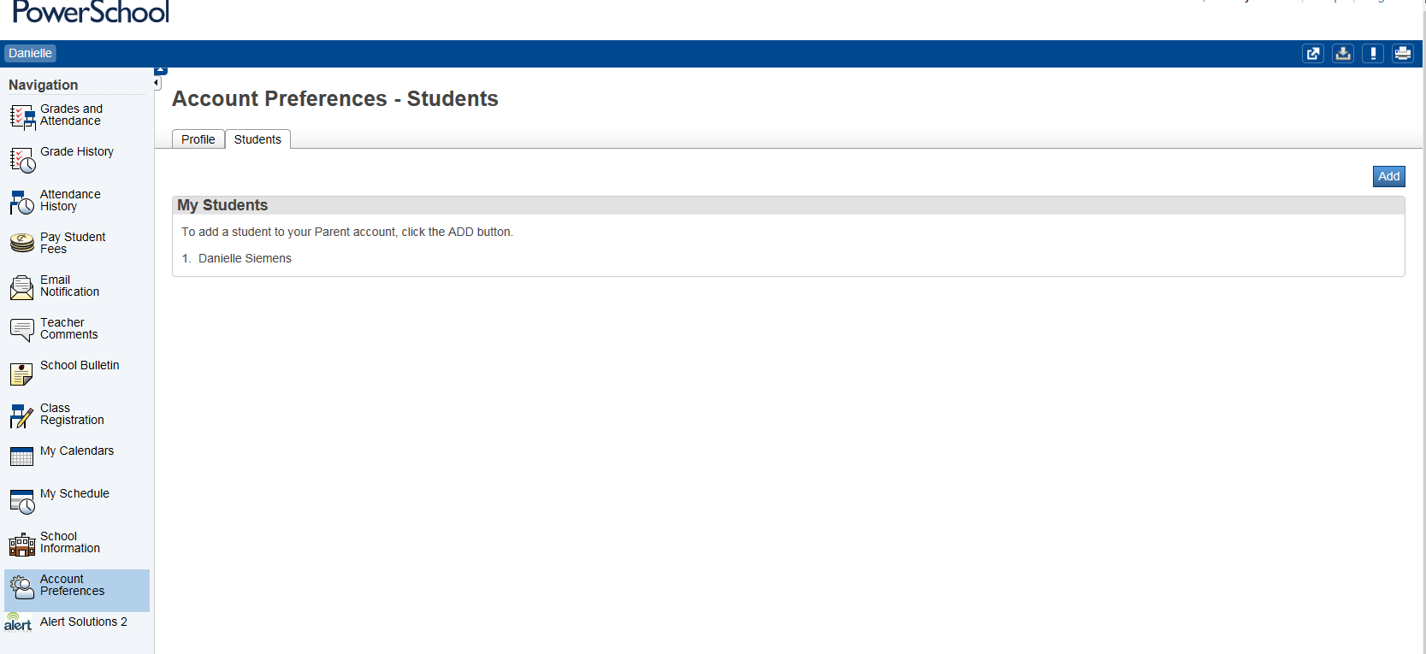

If you require any additional information or experience any problems contact the school office.

